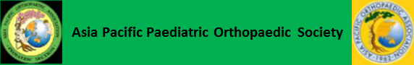

**Travelling Fellowship Application for APPOS 2025**

The APPOS is pleased to announce that applications for the 2025 travelling fellowship is now open for Orthopaedic Surgeons from the Asia-Pacific region

The Travelling Fellowship was established in 2015 to provide the opportunity for younger members of the orthopedic community with a substantive interest in pediaetric orthopaedics to expand their knowledge and develop links with colleagues in a country other than their own.

This year’s fellowship will be hosted by the Pediatric Orthopedic Society India and the Malaysian Pediatric Orthopedic Society.

Three fellows will be selected to spend two weeks travelling to substantive centres in India and Malaysia during which you will be exposed to a wide range of pediaetric orthopaedic practice, share experiences and present your research. The fellowship is completed by attending the APPOS meeting in Malaysia.

APPOS will cover the cost of economy-class airfare and provide a stipend of US$1,000 for each fellow. Accommodations in each country will be arranged by the host country's pediaetric orthopaedic society or hospital, and the participation fee for the APPOS meeting will be waived.

Friendships that develop during such fellowships will enrich your practice and provide long lasting links into the APPOS community.

Closing Date February 28th 2025

Send completed application, current curriculum vitae and references to APPOS secretary, Dr. Chia H. Chang (chiahchang@gmail.com) prior to the closing date.